CHAIN MATRIX MULTIPLICATION:
Code:
#include <stdio.h>
#include <limits.h>

int main()
{
int n, p[20], dp[20][20];
int i, j, k, len, cost;

printf("Enter number of matrices: ");
scanf("%d", &n);

printf("Enter %d dimensions: ", n + 1);
for (i = 0; i <= n; i++)
{
scanf("%d", &p[i]);
}

// Cost is 0 for one matrix
for (i = 1; i <= n; i++)
{
dp[i][i] = 0;
}

// Find minimum multiplication cost
for (len = 2; len <= n; len++)
{
for (i = 1; i <= n - len + 1; i++)
{
j = i + len - 1;
dp[i][j] = INT_MAX;

for (k = i; k < j; k++)
{
cost = dp[i][k] + dp[k + 1][j]
+ p[i - 1] * p[k] * p[j];

if (cost < dp[i][j])
{
dp[i][j] = cost;
}
}
}
}

printf("Minimum number of multiplications = %d\n", dp[1][n]);

return 0;
}

OUTPUT:
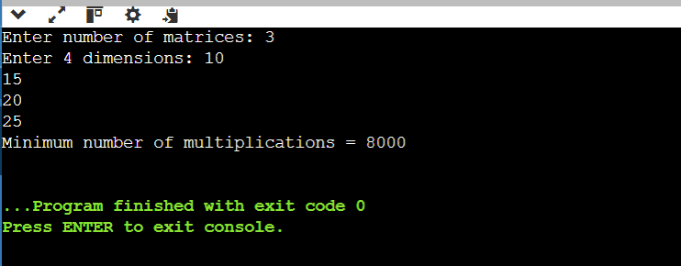

Conclusion:
Complexity | Value
Time Complexity | O(n³)
Space Complexity | O(n²)

